1. Set up more, and the one in the sidebar takes you to different pages.

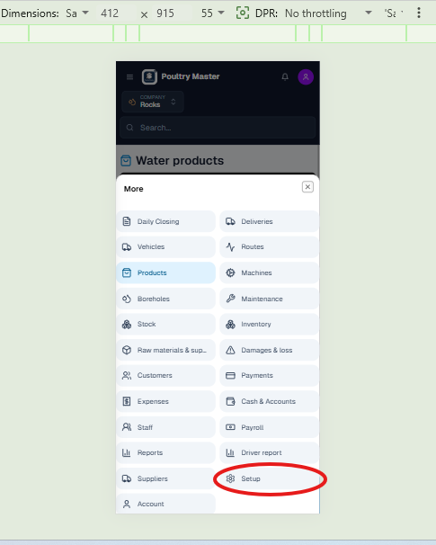
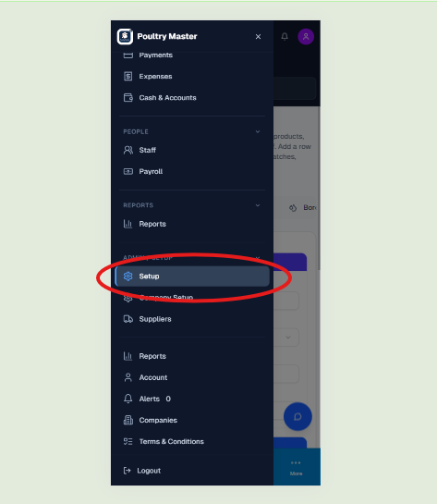

2. A: Clicking 'New Chat' does nothing

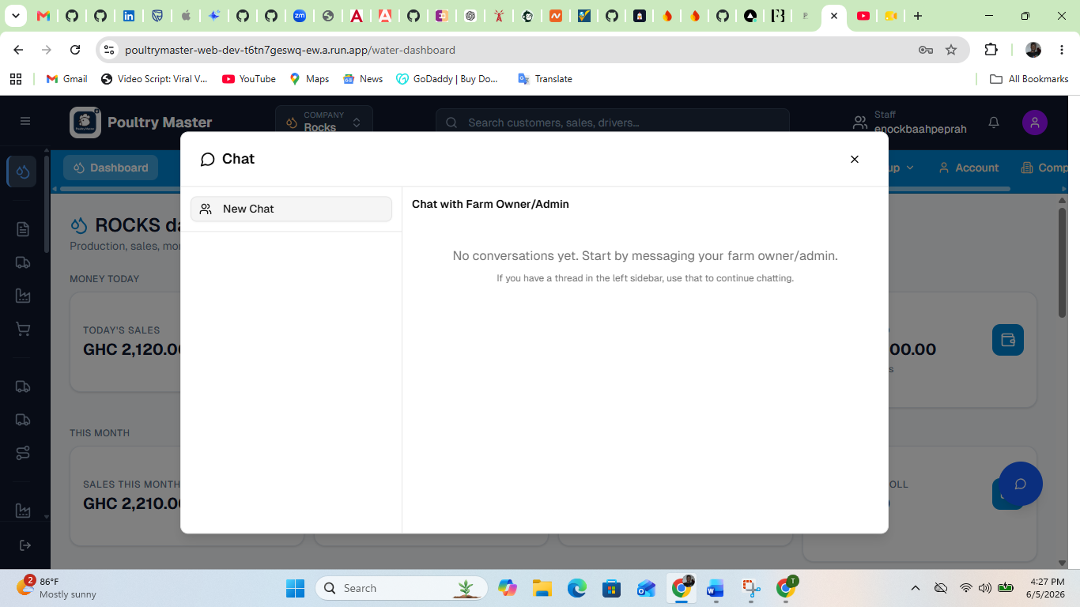

3. We have to work on responsiveness; some of the content doesn’t appear in mobile view and on smaller screens.

